How to run Project:

**Method 1:** To run individual feature

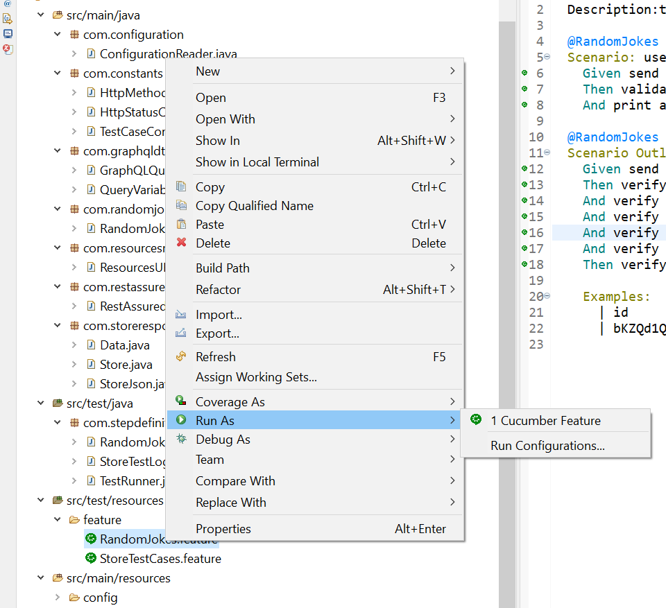

**Method 2:** To run complete test cases with TestRunner.java

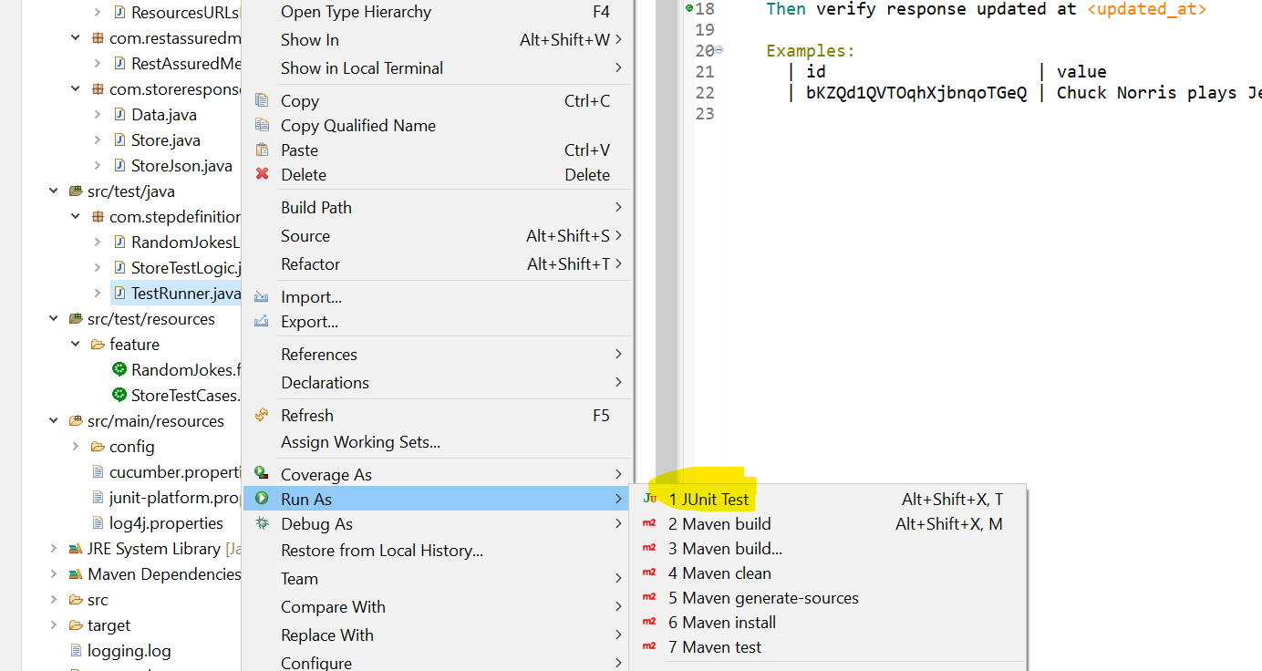

**Method 3:** To run with CMD

